Test Cases

Rectangle Collision
Before I implemented my triangle detection method, I had an idea for simple detection in rectangles. My plan was to take distance of the bullet from four corners of the rectangle and sum them up. If the bullet was within a certain distance that I set then the bullet would be considered to be in collision.

to check if this works, I tested every single pixel on the screen to see if they were considered to be colliding with my rectangle. If they didn't I painted them blue. If they did I left them white.

My expected outcome of this test was that only the rectangular part would be white. And if this idea didn't work then I would have to find a different method to detect collision.

The images below are the results of the test. Because of the rotating method I had inside of the plane class I was able to rotate the rectangle to different angles and see how it looks.
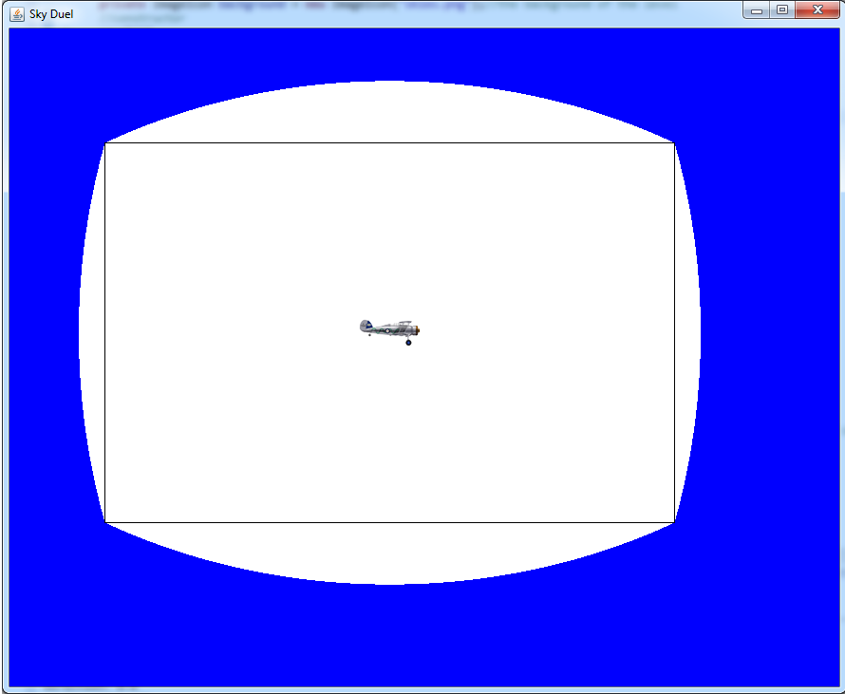
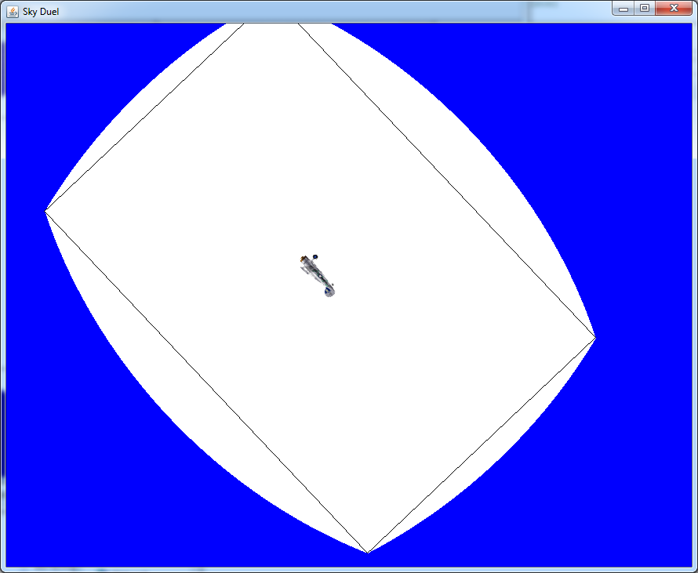
So the results didn't exactly match my prediction. The collision area was pretty close to a rectangle and I could have used that. But it wasn't really precise and it would be hard to fit it into the plane(unless I changed the plane's sprite to match the area). Anyway, I decided to find a better method to detect collision.

Triangle Collision
So I came up with the triangle collision method, which would be easier to implement into the plane. Since I can divide the sprite into triangles. I would be able to use this collision detection for any shape of sprite.

Similarly to the rectangle test, I passed in every pixel on the screen to see if they collided with the triangle.

What I expect see for each test case is that only the areas outside of the triangle will be painted blue. Leaving a white area in the middle.

In case if the triangle is not painted properly or not painted at all it would mean there is something wrong with calculation or logic inside the method. So the only solution would be to go over my code again to catch the problem. There was no other simpler collision method so I would probably stick to the triangle one anyway.

my test triangle had points at (100, 150) (700, 100) (650, 500)

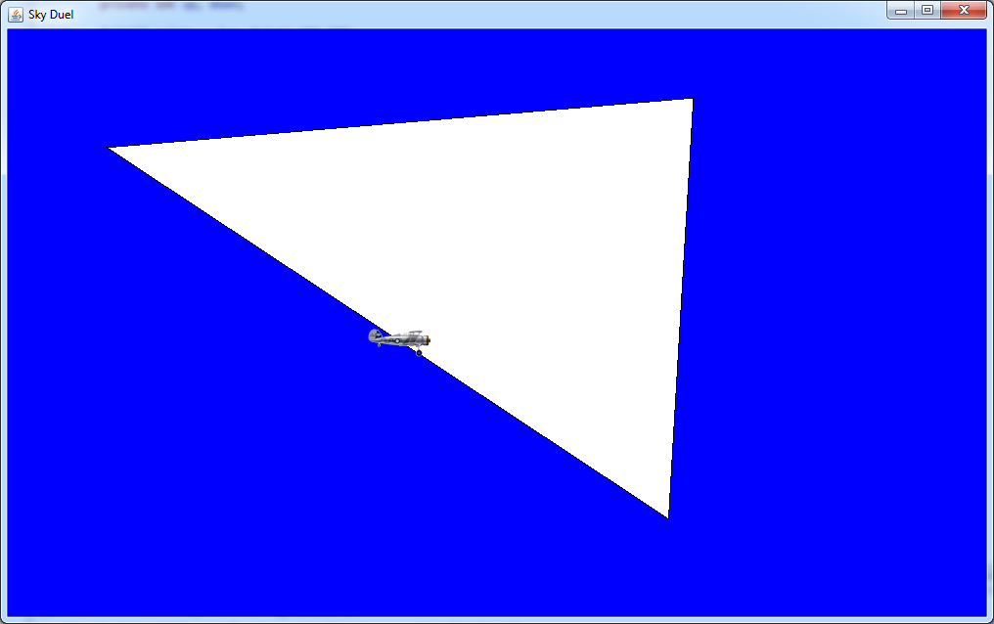

these are screenshots of my test case. The first picture shows the original triangle. Only the area outside is painted blue, therefore the collision detection worked. So then I rotated the triangle using arrow keys to get a new position of triangle(picture below). For this triangle the area outside remained blue, therefore the collision worked again.
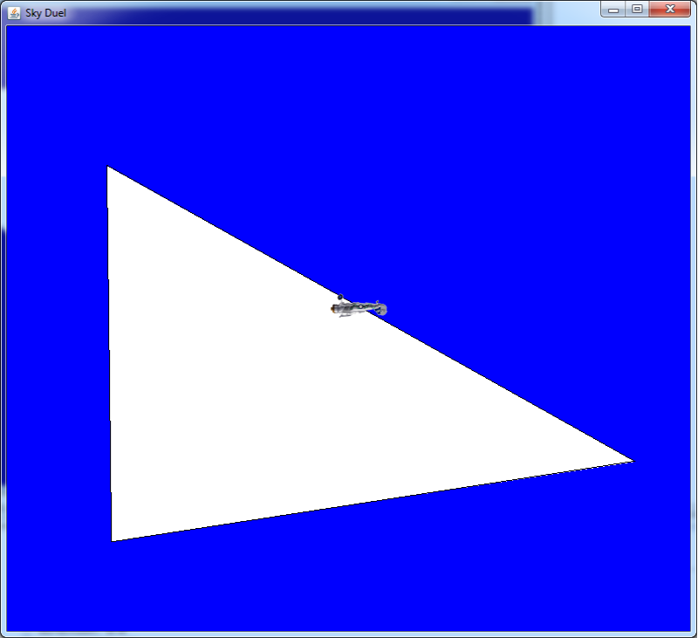
In this fashion I also tested a right triangles, small triangles and bunch of other triangles and rotated them to different angles. With each I got a positive result. Which meant that my method was working well.

Defining Collision Area
so after the triangle method worked, I moved onto defining the hit area for the plane. To find the coordinates of the triangles, I drew them in paint over the plane and by mousing over the points I was able to read them. The picture below shows those triangles.

Afterwards I inputed these points into my program and, again tested the collision by checking every pixel on the screen.

This time I decided to paint the colliding pixels with blue so that it's more visible.

My expected result was that the whole plane would be covered in blue area.

The first time I tested the method, nothing happened, therefore something was wrong. After much debugging, tracing and thinking, I realized I had a logic problem in my method. Whenever my program calculated that a point was not inside one of the triangles it would come to conclusion that the point wasn't colliding with the plane. Which is wrong because the point could be colliding with another triangle. So to fix the problem I made the method check through all the triangles before coming to conclusion that there was no collision. The result:

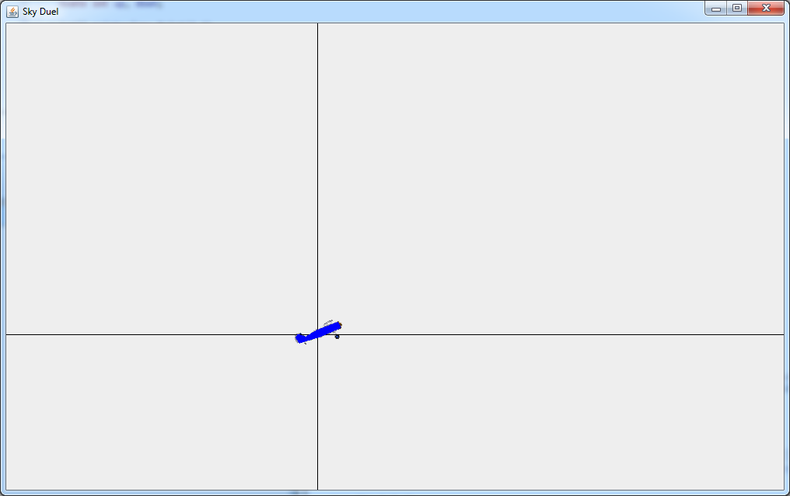

So now the plane was painted blue which indicated that collision detection was working properly.

